Long_prompts.py
total prompts: 1200
symbolic train: 420 prompts {'add': 105, 'sub': 105, 'mul': 105, 'div': 105}
symbolic test : 180 prompts {'add': 45, 'sub': 45, 'mul': 45, 'div': 45}
natural train: 420 prompts {'add': 105, 'sub': 105, 'mul': 105, 'div': 105}
natural test : 180 prompts {'add': 45, 'sub': 45, 'mul': 45, 'div': 45}

example prompts (one pair, both formats):
[symbolic] Please calculate 10 + 19 and tell me the final answer.
[symbolic] Please calculate 10 - 19 and tell me the final answer.
[symbolic] Please calculate 10 × 19 and tell me the final answer.
[symbolic] Please calculate 10 / 19 and tell me the final answer.
[natural] Please calculate the sum of 10 and 19 and tell me the final answer.
[natural] Please calculate the difference between 10 and 19 and tell me the final answer.
[natural] Please calculate the product of 10 and 19 and tell me the final answer.
[natural] Please calculate the quotient of 10 and 19 and tell me the final answer.

distinct final two words: {'final answer.'}

A dataset of 1200 prompts for the probe experiments. It has two versions of every prompt:
Symbolic: “Please calculate 10 + 19 and tell me the final answer.”
Natural language: “Please calculate the sum of 10 and 19 and tell me the final answer.”
The structure is 50 operand pairs × 4 operations × 3 sentence templates × 2 formats = 1200.
randomly picked 50 operand pairs from the numbers 2 to 30. Then I held out 15 whole pairs for testing and used the other 35 for training. (10, 19) and (19, 10) count as the same pair)

Extracting hidden states once, save the vectors to a file for later steps
probe_states.py
100/1200 done
200/1200 done
300/1200 done
400/1200 done
500/1200 done
600/1200 done
700/1200 done
800/1200 done
900/1200 done
1000/1200 done
1100/1200 done
1200/1200 done

groups with unequal lengths across ops: 0
saved probe_states.npz last=(1200, 25, 896) operand=(1200, 25, 896)

[symbolic] Please calculate 10 + 19 and tell me the final answer.
operand token #8 = '9'
last token #15 = '.'

[symbolic] I need you to compute 10 - 19 and give me the final answer.
operand token #11 = '9'
last token #18 = '.'

the tokens are Please, calculate, , 1, 0, +, , 1, 9, so #8 = '9' is right.
0 groups with unequal lengths. The / fix worked, so no op can be identified from prompt length.
Shapes (1200, 25, 896) for both positions.

Layer by layer operation probing:
For every layer, we train a linear classifier on hidden states from the 35 training pairs and test it on the 15 held-out pairs. We do this separately for each token position. That answers “at which layer can the operation be read off, even for numbers the probe never saw?”
Train_probe.py
(kv_cache_env) hhlong@Longs-M3-Pro qwen2.5 % python train_probe.py
layer symbolic/last symbolic/operand natural/last natural/operand
0 0.250 0.250 0.250 0.250
1 0.994 1.000 1.000 0.983
2 1.000 1.000 1.000 1.000
3 1.000 1.000 1.000 0.994
4 1.000 1.000 1.000 1.000
5 1.000 1.000 1.000 1.000
6 1.000 1.000 1.000 0.994
7 1.000 1.000 1.000 1.000
8 1.000 1.000 1.000 1.000
9 1.000 1.000 1.000 1.000
10 1.000 1.000 1.000 1.000
11 1.000 1.000 1.000 1.000
12 1.000 1.000 1.000 1.000
13 1.000 1.000 1.000 1.000
14 1.000 1.000 1.000 1.000
15 1.000 1.000 1.000 1.000
16 1.000 1.000 1.000 1.000
17 1.000 1.000 1.000 1.000
18 1.000 1.000 1.000 1.000
19 1.000 1.000 1.000 1.000
20 1.000 1.000 1.000 1.000
21 1.000 1.000 1.000 1.000
22 1.000 1.000 1.000 1.000
23 1.000 1.000 1.000 1.000
24 1.000 1.000 1.000 1.000

symbolic/last, layer 0: per-op acc add=1.00 sub=0.00 mul=0.00 div=0.00
rows = true, cols = predicted add sub mul div
add 45 0 0 0
sub 45 0 0 0
mul 45 0 0 0
div 45 0 0 0

symbolic/last, layer 4: per-op acc add=1.00 sub=1.00 mul=1.00 div=1.00
rows = true, cols = predicted add sub mul div
add 45 0 0 0
sub 0 45 0 0
mul 0 0 45 0
div 0 0 0 45

symbolic/last, layer 12: per-op acc add=1.00 sub=1.00 mul=1.00 div=1.00
rows = true, cols = predicted add sub mul div
add 45 0 0 0
sub 0 45 0 0
mul 0 0 45 0
div 0 0 0 45

symbolic/last, layer 20: per-op acc add=1.00 sub=1.00 mul=1.00 div=1.00
rows = true, cols = predicted add sub mul div
add 45 0 0 0
sub 0 45 0 0
mul 0 0 45 0
div 0 0 0 45

control (shuffled train labels, symbolic/last, layer 12): 0.233
2026-10-14 11:54:22.875 Python[83637:5401346] ApplePersistenceIgnoreState: Existing state will not be touched. New state will be written to /var/folders/3d/rwrvy7k96g372pltqg_bd9l80000gn/T/org.python.python.savedState

saved probe_accuracy_by_layer.png and probe_results.json

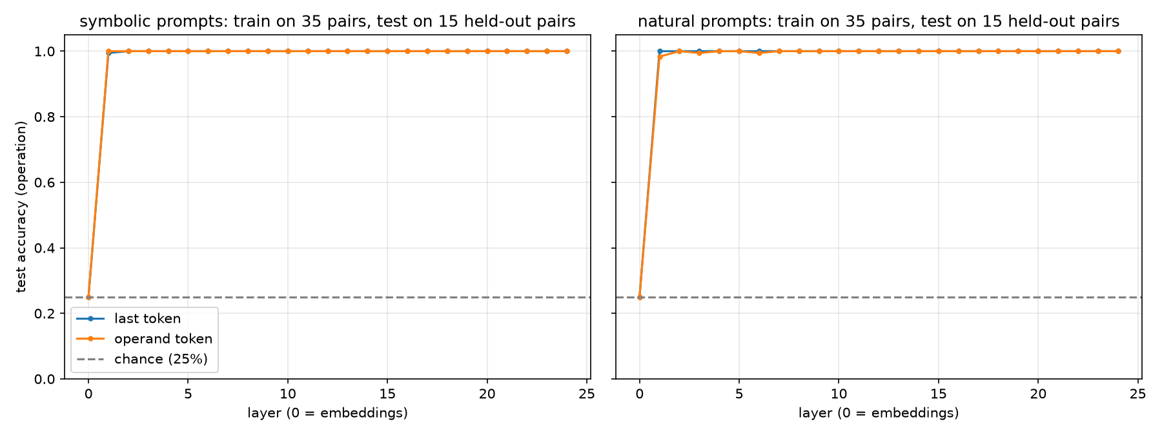
Layer 0, last token ≈ 0.25. The . embedding is identical everywhere, so it has no info. If this isn’t at chance, something’s wrong.
Layer 0, operand token ≈ 0.25 too. It’s just the embedding of a digit.

Jump by layer 1, or 2
Test accuracy is basically 100% on operand pairs the probe never saw, at both positions and in both formats.
The last token is the important one. It’s the same . in every prompt, so the op info there was moved in by attention in a single layer. It then stays readable all the way to the output.
- Operation can be decoded independently of the operands, starting at layer 1

Cross wording transfer:

=== position: last ===
layer sym->nat sym->nat/centered nat->sym nat->sym/centered
0 0.250 0.250 0.250 0.250
1 0.328 0.228 0.250 0.228
2 0.278 0.311 0.167 0.378
3 0.250 0.278 0.250 0.367
4 0.250 0.233 0.250 0.344
5 0.322 0.283 0.444 0.344
6 0.333 0.339 0.311 0.372
7 0.333 0.539 0.550 0.617
8 0.294 0.439 0.444 0.744
9 0.378 0.589 0.450 0.722
10 0.383 0.506 0.617 0.711
11 0.644 0.817 0.728 0.900
12 0.611 0.789 0.506 0.783
13 0.606 0.772 0.600 0.772
14 0.650 0.806 0.722 0.783
15 0.822 0.928 0.817 0.922
16 0.806 0.906 0.761 0.878
17 0.722 0.906 0.789 0.861
18 0.694 0.811 0.778 0.844
19 0.683 0.906 0.772 0.867
20 0.750 0.894 0.789 0.883
21 0.917 0.983 0.789 0.889
22 0.928 0.983 0.817 0.867
23 0.872 0.994 0.833 0.878
24 0.872 0.989 0.900 0.889

=== position: operand ===
layer sym->nat sym->nat/centered nat->sym nat->sym/centered
0 0.250 0.250 0.250 0.250
1 0.500 0.278 0.372 0.311
2 0.250 0.422 0.356 0.244
3 0.522 0.522 0.483 0.550
4 0.472 0.578 0.756 0.939
5 0.478 0.628 0.656 0.900
6 0.489 0.672 0.967 0.922
7 0.583 0.744 0.911 0.922
8 0.594 0.967 1.000 0.994
9 0.922 1.000 1.000 1.000
10 0.800 1.000 0.972 1.000
11 0.878 1.000 1.000 1.000
12 0.889 1.000 1.000 1.000
13 0.783 1.000 1.000 0.994
14 0.794 0.994 1.000 0.994
15 0.917 1.000 1.000 1.000
16 0.844 1.000 1.000 1.000
17 0.972 0.994 1.000 1.000
18 0.956 0.994 1.000 1.000
19 0.922 0.989 0.989 1.000
20 0.911 0.983 0.911 1.000
21 0.956 0.967 0.900 0.994
22 0.967 0.928 0.794 1.000
23 0.906 0.906 0.750 0.989
24 0.844 0.933 0.783 1.000

sym->nat/last, layer 2: acc 0.278
rows = true, cols = predicted add sub mul div
add 44 1 0 0
sub 39 6 0 0
mul 41 4 0 0
div 40 5 0 0

sym->nat/last, layer 8: acc 0.294
rows = true, cols = predicted add sub mul div
add 38 7 0 0
sub 30 15 0 0
mul 30 15 0 0
div 25 15 5 0

sym->nat/last, layer 14: acc 0.650
rows = true, cols = predicted add sub mul div
add 45 0 0 0
sub 2 39 0 4
mul 43 0 2 0
div 12 0 2 31

sym->nat/last, layer 20: acc 0.750
rows = true, cols = predicted add sub mul div
add 45 0 0 0
sub 0 44 1 0
mul 28 0 17 0
div 0 2 14 29

2026-10-14 12:02:56.455 Python[94455:5444504] ApplePersistenceIgnoreState: Existing state will not be touched. New state will be written to /var/folders/3d/rwrvy7k96g372pltqg_bd9l80000gn/T/org.python.python.savedState

saved cross_wording_by_layer.png and cross_wording_results.json

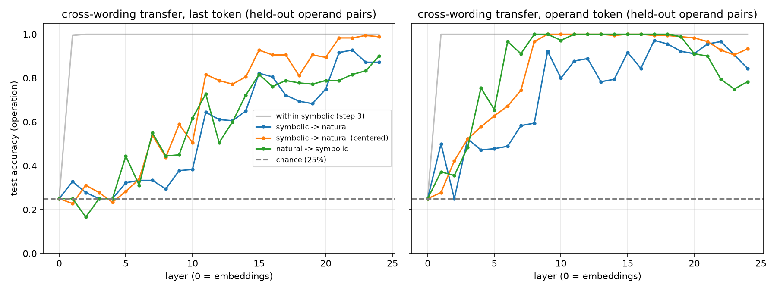

This separates the remember the symbol from knows the operation, which train_probe couldn’t do
At the last token, a probe trained only on symbolic prompts can’t recognize natural-language prompts until about layer 7. It climbs through the middle layers and reaches ~80 to 90% by layer 11 to 15 and ~90 to 99% by layer 21 to 24. Both directions (sym→nat and nat→sym) show the same shape, so it isn’t a fluke of one direction.

Layers 1 to ~6: the op is fully readable, but only in a format-specific way. It looks like “there was a + token” or “there was the word sum”, and those don’t share a direction.
Layers ~7 to 15: + and “the sum of” increasingly land in the same direction. This is where a wording-independent “what computation was requested” representation shows up.
Layers 15 to 24: it gets sharper and is near ceiling (centered) by the end.

Operand Probing:
Last token, layer 0: R² ≈ 0 (or slightly negative), and cosine = 1.0, since every vector there is the same . embedding. Same sanity check as before.
Operand token, layer 0, b: probably a low R². At that point the vector only “knows” the last digit of b (the 9 in 19), not the full number. Watch for the layer where R² for b jumps, because that’s roughly where the model has combined 1 and 9 into “nineteen”.
The main comparison: does R² at the last token stay high in the layers where cosine is climbing? If yes, the operands are still encoded. They just make up a smaller share of the vector than the shared stuff (op, sentence frame, “about to answer”) that drives cosine up.
a vs b at the last token: a is further back in the sentence, so it may be harder to read off. If so, that’s worth noting.

=== symbolic: R^2 on held-out pairs (and last-token operand-only cosine) ===
layer last/a last/b operand/a operand/b cos(last)
0 -0.031 -0.003 -0.431 0.075 1.0000
1 0.192 0.829 0.038 1.000 0.9998
2 0.809 0.944 0.874 0.999 0.9998
3 0.775 0.935 0.645 0.995 0.9997
4 0.939 0.950 0.799 0.992 0.9996
5 0.966 0.896 0.825 0.989 0.9985
6 0.969 0.892 0.831 0.989 0.9979
7 0.943 0.883 0.776 0.991 0.9975
8 0.946 0.881 0.831 0.975 0.9979
9 0.964 0.924 0.898 0.976 0.9980
10 0.946 0.921 0.907 0.979 0.9983
11 0.941 0.930 0.871 0.981 0.9972
12 0.963 0.910 0.876 0.984 0.9968
13 0.941 0.922 0.865 0.977 0.9967
14 0.938 0.932 0.864 0.984 0.9968
15 0.937 0.931 0.897 0.987 0.9970
16 0.936 0.933 0.872 0.988 0.9973
17 0.948 0.933 0.925 0.990 0.9974
18 0.946 0.919 0.939 0.987 0.9975
19 0.943 0.904 0.930 0.987 0.9973
20 0.951 0.903 0.910 0.989 0.9966
21 0.942 0.914 0.924 0.983 0.9974
22 0.952 0.913 0.899 0.988 0.9981
23 0.951 0.913 0.889 0.985 0.9974
24 0.952 0.911 0.870 0.969 0.9959

=== natural: R^2 on held-out pairs (and last-token operand-only cosine) ===
layer last/a last/b operand/a operand/b cos(last)
0 -0.031 -0.003 -0.431 0.075 1.0000
1 0.203 0.737 0.284 1.000 0.9996
2 0.429 0.885 0.845 1.000 0.9998
3 0.868 0.915 0.548 0.998 0.9997
4 0.891 0.932 0.755 0.994 0.9996
5 0.915 0.896 0.787 0.992 0.9989
6 0.914 0.824 0.837 0.993 0.9986
7 0.885 0.852 0.841 0.994 0.9985
8 0.933 0.837 0.912 0.987 0.9987
9 0.930 0.903 0.884 0.988 0.9987
10 0.952 0.914 0.861 0.987 0.9989
11 0.919 0.940 0.900 0.989 0.9984
12 0.953 0.912 0.863 0.990 0.9982
13 0.944 0.910 0.891 0.992 0.9979
14 0.948 0.925 0.901 0.992 0.9980
15 0.952 0.917 0.927 0.992 0.9979
16 0.947 0.925 0.919 0.993 0.9982
17 0.944 0.918 0.940 0.995 0.9983
18 0.949 0.920 0.932 0.992 0.9984
19 0.940 0.913 0.937 0.994 0.9983
20 0.936 0.899 0.952 0.994 0.9978
21 0.950 0.906 0.963 0.995 0.9982
22 0.953 0.908 0.956 0.994 0.9988
23 0.960 0.887 0.949 0.992 0.9982
24 0.959 0.875 0.923 0.979 0.9973

mean absolute error (in units) at a few layers, symbolic:
layer 0: last/a=6.94 last/b=8.24 operand/a=8.48 operand/b=8.16
layer 4: last/a=1.38 last/b=1.55 operand/a=2.43 operand/b=0.54
layer 12: last/a=1.20 last/b=2.10 operand/a=2.16 operand/b=0.82
layer 20: last/a=1.33 last/b=2.15 operand/a=1.85 operand/b=0.74
layer 24: last/a=1.32 last/b=2.13 operand/a=2.15 operand/b=1.21
2026-10-14 12:13:29.127 Python[7081:5489443] ApplePersistenceIgnoreState: Existing state will not be touched. New state will be written to /var/folders/3d/rwrvy7k96g372pltqg_bd9l80000gn/T/org.python.python.savedState

saved operand_probes_by_layer.png and operand_probe_results.json

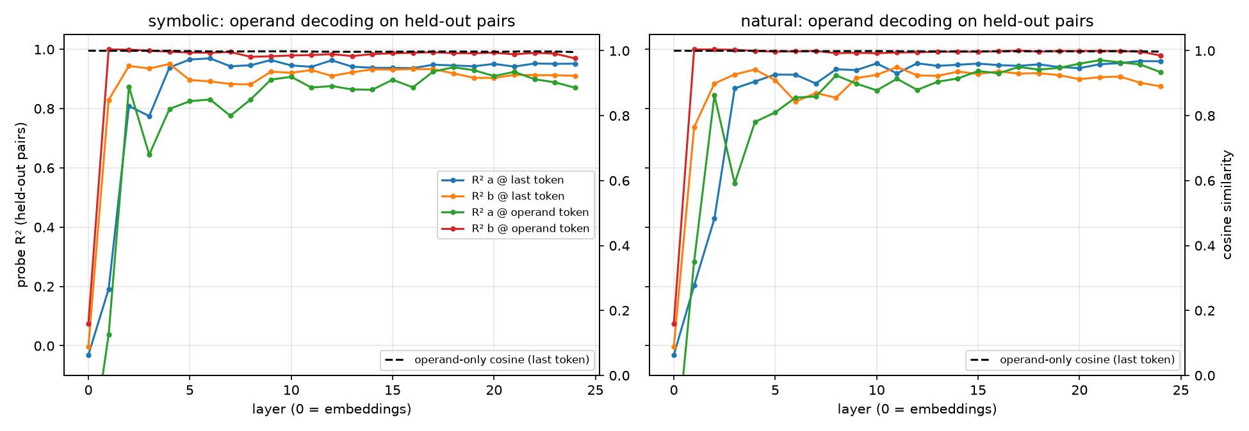
The operands don’t fade away, both a and b stay linearly at most every layer, even though the hidden states for different operands prompts have cosine sims of around 0.997

